Exp 11

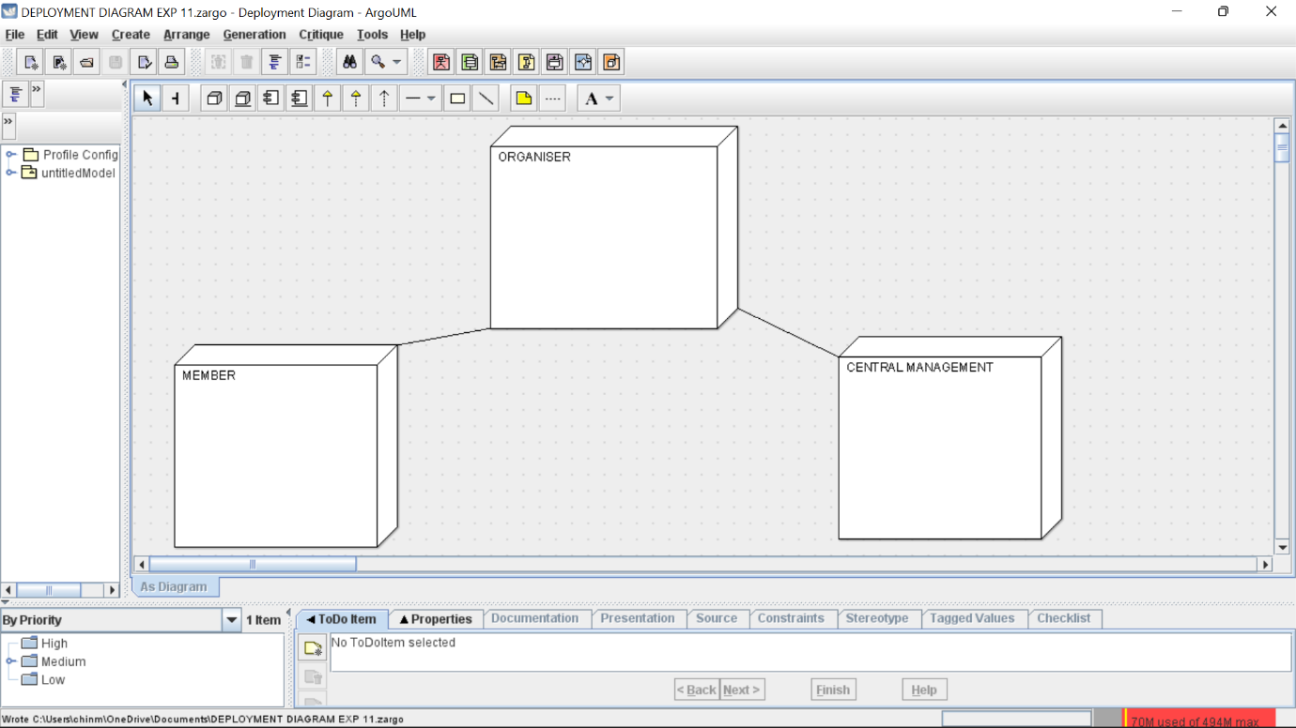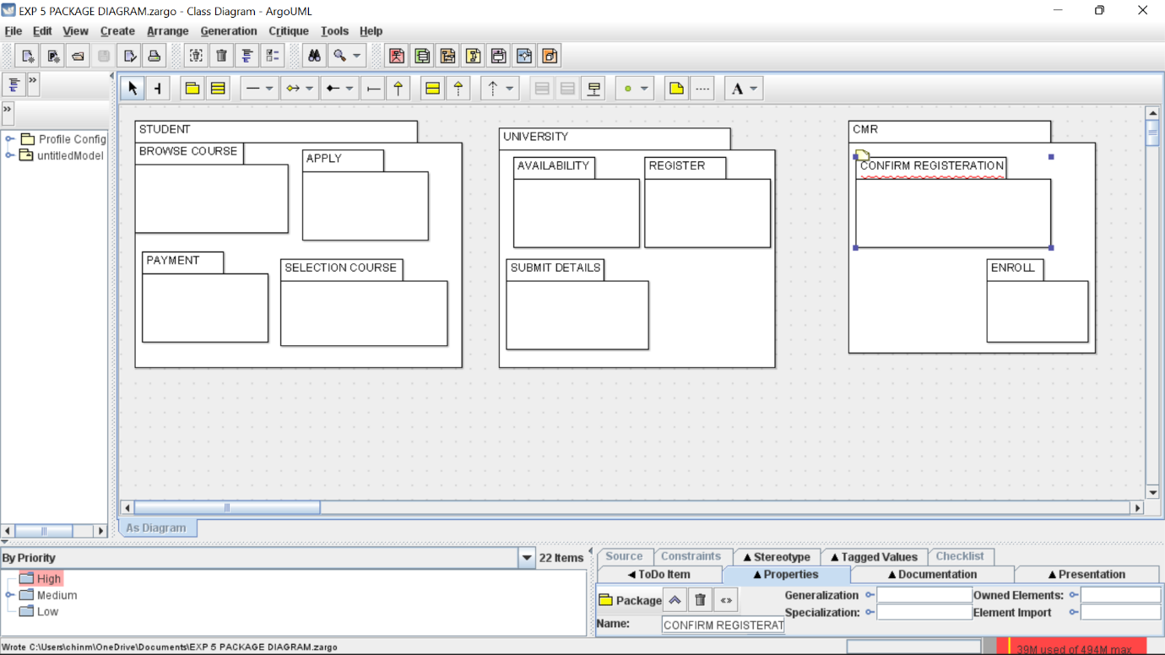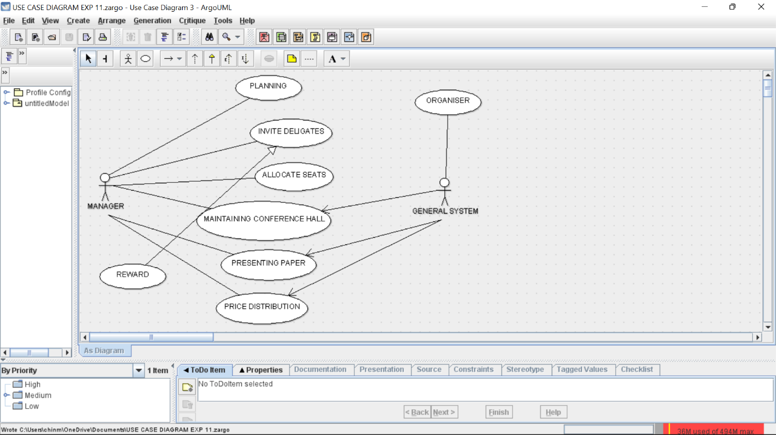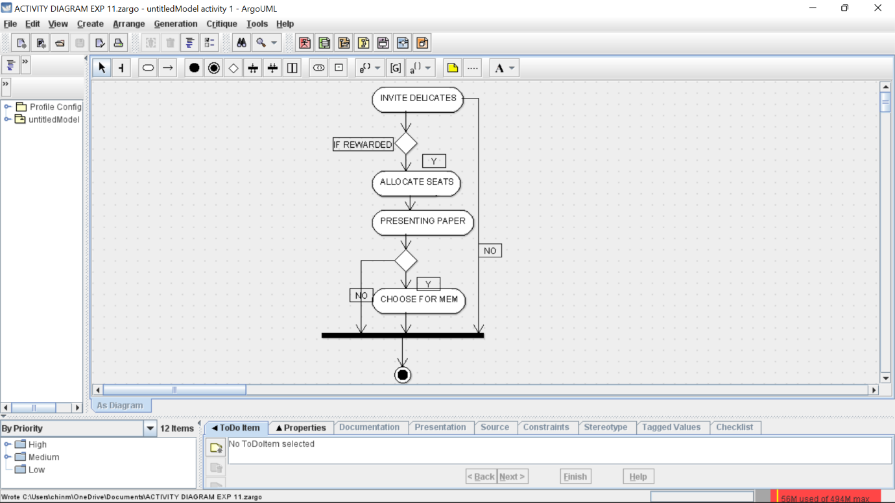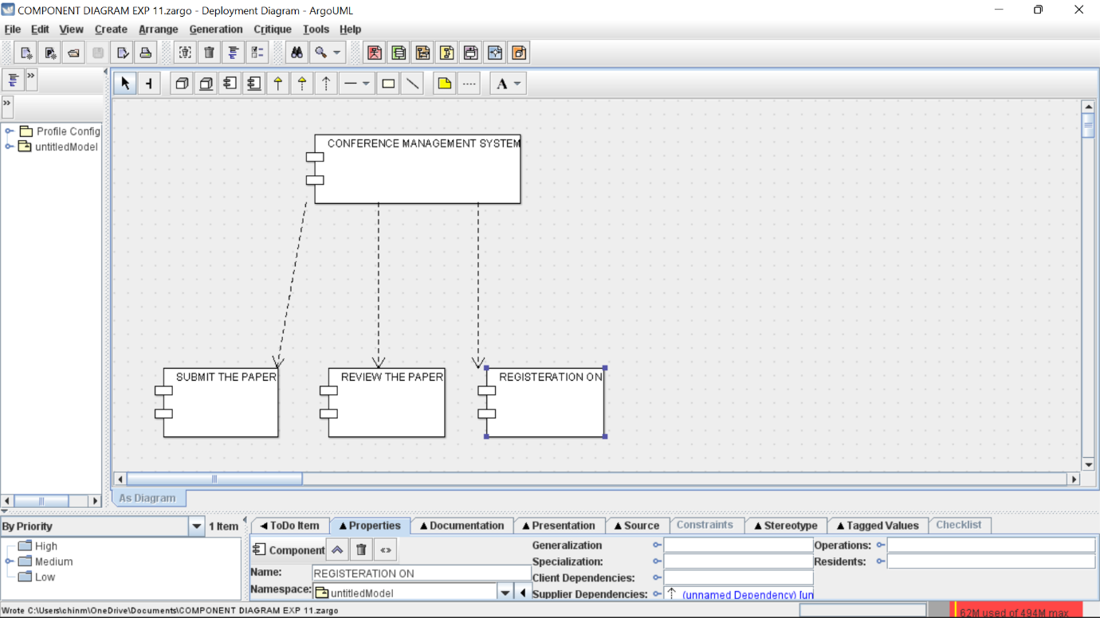

Skeleton code

import java.util.Vector;

public class CENTRAL MANAGEMENT {

private Integer DETAILS;

public Integer FUNCTION;

public Integer SEAYALLOCATIONS;

public Vector myMANAGER;

public void UPDATING() {

}

public void STORING() {

}

public void CMS() {

}

}

public class MANAGER {

public Integer NAME;

public Integer PROOF;

public Integer ID;

private void PAPER() {

}

public void WINNINGPRICES() {

}

public void MEMBER() {

}

}

import java.util.Vector;

public class ORGANISER {

public Integer FUNCTIONDETAILS;

public Integer MEMBERDETAILS;

public Vector myMANAGER;

public void INVITINGDELICATES() {

}

public void ALLOCATINGSEATS() {

}

}